Section 1: System Architect

1.1 Introduction
Adaptiv Health system will be developed as a smart cardiovascular monitoring system with an artificial intelligence platform capable of integrating wearable smart devices, mobile edge processing, and analytical cloud computing to guide users with safe, personal, and continuous heart-health advice. Physiological signals that are captured using wearable sensors include heart rate, blood oxygen saturation, blood pressure, and heart-rate variability, which are sent to the Adaptiv mobile application to be analyzed instantaneously. With the help of TensorFlow Lite, the smartphone can run time risk scoring, activity segmentation, and missing-data processing, allowing it to provide instant notification without the use of the cloud.

In addition to edge processing, Adaptiv Health uses a secure backend on AWS, in which Python-based microservices perform more advanced analytics, clean batch data and update long-term models. Encrypted PostgreSQL databases hold the protected health information, and a role-based React dashboard enables the clinician or the administrator to access the trends of patients, alerts, and cardiovascular risk evaluation. The system guarantees end-to-end security using the HIPAA-congruent encryption, authorized access, and regulated data flows.

This design document gives the overview of the system architecture, data structure, processing logic and component interactions. It describes how Adaptiv Health transforms raw wearable data into useful insights, the complementary nature of real-time and cloud-based processing, and the system as to how it has ensured safety, scalability, and privacy in its operations.

1.2 Purpose
The purpose of the Adaptiv Health system is to provide a progressive, AI-supported cardiovascular monitoring and guidance platform that enhances safety, recovery, and prevention for individuals with cardiovascular risks.
The system uses:
- Wearable smart devices to collect real-time physiological signals.
- Edge AI (TensorFlow Lite) to provide <160ms risk alerts directly on the smartphone.
- Cloud-based analytics (AWS EC2 + RDS PostgreSQL) to train long-term models, store PHI, and generate personalized insights.
- A patient mobile app (Flutter) and clinician dashboard (React) to deliver daily recommendations, trends, safety alerts, and structured health summaries.
Adaptiv Health is not a diagnostic tool but a supportive platform that helps users understand their physical limits and avoid unsafe levels of exertion. Through instant alerts, adaptive recommendations, and long-term trend analysis, the system empowers users to manage their cardiovascular health more effectively while ensuring regulatory compliance through HIPAA- and GDPR-aligned data handling.

1.3 Scope
The scope of Adaptiv Health spans the full lifecycle of cardiac data acquisition, analysis, storage, and visualization. The system combines IoT sensors, mobile edge AI, cloud computing, and role-based dashboards to deliver both real-time and long-term cardiovascular insights.

In Scope
The system includes:
- Wearable data acquisition using FDA-approved or validated smart devices capable of capturing HR, SpO₂, BP, HRV, and activity metrics.
- Mobile edge processing, where the smartphone app (Flutter) performs real-time risk scoring using TensorFlow Lite, signal smoothing, and missing-data imputation.
- Cloud analytics, including:
  - Python-based microservices hosted on AWS EC2,
  - long-term AI model training,
  - batch data cleaning,
  - secure storage of PHI in encrypted PostgreSQL databases (AWS RDS).
- A clinician and admin dashboard built with React that provides role-based access to trends, alerts, historical data, and patient summaries.
- Security and compliance mechanisms, including TLS 1.3, AES-256 encryption, RBAC, and HIPAA practices.

Out of Scope
The current system does not include:
- Medical diagnosis or clinical decision-making.
- Emergency medical response or automated EMS notifications.
- Hospital EMR integration or clinical-grade ECG interpretations.
- AI detection of rare cardiac abnormalities requiring FDA medical-device certification.

1.4 Glossary & Definitions
This glossary defines key technical and health-related terms used throughout the Adaptiv Health system.

AI and Data Processing Terms
- Edge AI: On-device machine learning execution using TensorFlow Lite, enabling real-time risk assessments without cloud dependency.
- TensorFlow Lite: A lightweight neural network framework optimized for mobile inference, used for performing risk scoring within milliseconds.
- KNNImputer: A preprocessing technique used to fill short gaps in wearable data based on nearest-neighbor signal similarities.
- Normalization: Converting raw biometric values into standardized formats for machine-learning models.
- Reinforcement Learning: A model-training approach used to refine personalized exercise prescriptions based on past performance and outcomes.
- LSTM: Long Short-Term Memory networks designed for sequential physiological data such as heart rate trends.
- CNN: Convolutional Neural Networks often used for analyzing ECG or PPG waveform patterns.
- XGBoost: A high-performance gradient boosting algorithm commonly used in cardiovascular risk classification.
- U-Net: A deep-learning architecture used for medical signal segmentation (e.g., ECG/PPG waveform regions).
- CLAHE: A signal enhancement method (Contrast Limited Adaptive Histogram Equalization) used to improve clarity and reduce noise in physiological signals.

Sensor and Medical Terms
- PPG (Photoplethysmography): An optical technique used by wearables to measure HR and SpO₂.
- ECG: Electrical measurement of heart activity, often used in arrhythmia detection.
- HRV: Heart Rate Variability, a measure of autonomic function and recovery.
- SpO₂: Percentage of oxygen saturation in the blood.

Cloud and Security Terms
- AWS EC2: Cloud compute servers running backend microservices and ML pipelines.
- AWS RDS PostgreSQL: Encrypted relational database used to store PHI securely.
- API Gateway: The secure entry point for all device-to-cloud and client-to-cloud communication.
- AES-256: Encryption standard for protecting stored PHI.
- TLS 1.3: Encryption protocol used for secure data transmission.
- Role-Based Access Control (RBAC): Access model that restricts dashboard features based on user type.

Section 2: Overview

Adaptive health is an integrated progressive health monitoring platform for cardiovascular patients to improve their cardiovascular health by detecting their health metrics using wearable smart devices and assigning them personalized health plans using AI based on cardiovascular conditions determined by giving a risk score. This is not a diagnosis system but more of a support system. It uses smart devices to collect physiological data that is processed in edge AI for risk alerts and Advanced cloud analytics for training data and updating health progress. Physicians and admins have role-based access to the patient monitoring dashboard for patient health analysis. All data is end-to-end encrypted and meets privacy protocol standards for HIPAA.

Section 3: High-Level Architecture
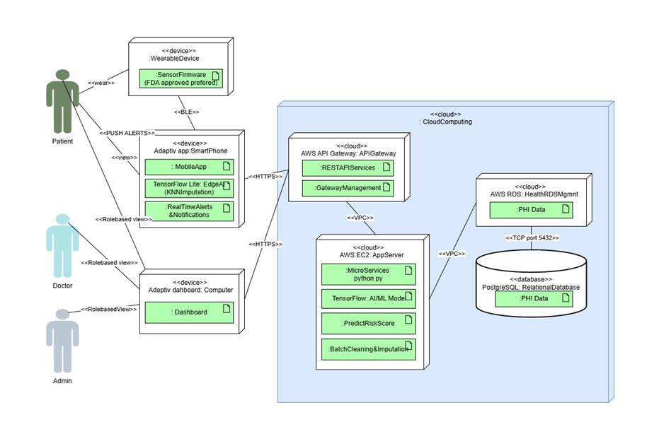

The architecture consists of Four main components:

- Wearable smart devices with FDA approved sensor firmware are required to collect physiological health data.

- Smartphone Application: We will use flutter to build the app. It will have Edge AI designed using TensorFlow Lite. It does imputation and executes real-time risk alerts.

- Dashboard Client: Build with React. Role-based computer view provides admin or clinician views of patient data, alerts, and trends.

- Cloud Platforms:
  - API Gateway: AWS API Gateway Manages all REST API requests, traffic, and logging.
  - AWS EC2 cloud services: Hosts backend Python microservices, machine learning models, risk scoring model, and data batch cleaning along with imputation.
  - AWS RDS PostgreSQL: Stores Protected personal Health Information and provides complex relational queries for clinical use and handles thousands of users at the same time.

3.1 Main Architecture Diagram Description

- Data flow: Wearable smart devices gather data and send to smartphone Adaptiv apps using BLE for immediate AI analysis using edge AI. The app transmits critical health data as payloads between regular intervals to the cloud via HTTPS.

- Cloud flow: API Gateway acts as the secure entry point for all external and internal requests. Backend AWS EC2 servers process data and act as the business layer of our system and cleans data, runs ML models, and predicts risk scores. AWS RDS PostgreSQL is part of the data layer that stores all the data of the users. Communication between these cloud services occurs through AWS’ virtual private cloud.

- Dashboard flow: Role-based view enabled dashboard connects to the API Gateway to view patient data, alerts, and trends, all via secure channels.

3.2 Subsystem Descriptions

- Sensor & Firmware Subsystem: App recommends FDA approved wearable device firmware to collect physiological metrics, validates data, and transmits securely via bluetooth to paired smartphones.

- Mobile Edge AI Subsystem: The app designed using Flutter for inter OS operability, with TensorFlow Lite for Edge AI, performs rapid imputation using KNNImputer, risk assessment, and instant alert notifications. IT reduces latency by avoiding cloud for quick analytics minimizing cloud dependency and provides privacy.

- Backend Microservices & ML Analytics: AES EC2 runs Python based microservices for batch cleaning, executes ML models for deep personalized analytics of user data it then forwards personalized health care regiments to user, app, and responds to dashboard requests.

- Storage & Archives Subsystem: AWS RDS (PostgreSQL): PostgreSQL is used for storage of large numbers of users and performing complex queries. AWS RDS manages PostgreSQL and encrypts data with AES 256 for HIPAA compliance.

- Dashboard Subsystem: Dashboard designed using React for cross-platform compatibility and security provides role-based access, data visualization, alert history, and reporting. All Communicated channels are only via HTTPS and secure ports for compliance.

3.3 Reducing design costs through trade-offs and design rationale.

The architecture of the system was created with the balance of reliability, latency, scalability, and user safety, which align with the learning outcomes under the category of systems design and evaluation (LO5, LO6) with the CSIT321 course.

3.3.1 Along device vs Cloud Processing.

Rationale:
The limits can consist of mobile hardware, battery efficiency, and model complexity versus on-device ML, which comes with reduced latency.

Trade-off:
Alternative to select approach: Hybrid model occurred, which is lightweight preprocessing on device and full inference on cloud.
Rationale: BEnables live feedback and allows higher computationally intensive cardiovascular risk models.

This section describes the communication protocols that underpin the application: BLE, REST, and WebSockets (Bigdata) 3.3.2.

Rationale:
BLE is the best to be used in wearable - phone communication because it is energy efficient and is widely used.
REST can be trusted with transactional information, and WebSockets can be trusted with real-time streams on the dashboard of the doctor.

Trade-off:
Weightedness REST will not ensure low-latency dashboards - WebSockets selected.
Environment - local buffering applied may influence stability in BLE.

3.3.3 Database Choice (NoSQL vs SQL)

Rationale:
Physiological data is of high-frequency and time series, but Adaptiv health performs aggregation within Edge AI and sends hourly summaries and key events in payloads to the cloud. All the data is better stored in a structured relationship schema with clear relationships.

Trade-off: NoSQL can store raw, unstructured data from sensors well but this creates complexity.

Selected: A single SQL database with JSONB support can store PHI and user profiles in relational tables while flexible preferences can live in JSONB columns.

3.3.4 AI Model Selection

Rationale:
The system requires fast analysis in cases of emergency, so it requires an Edge AI as well as a cloud AI for advanced analytics.
Trade-off:
Edge AI can’t be a deep learning model as it can increase computational cost, latency and battery usage of smartphones. Simple models have the risk of missing subtle cardiovascular abnormalities or may produce false positives.
Selection: Edge safety alerts use lightweight TensorFlow Lite Edge AI model while deeper LSTM models on AW EC2 can do advanced analytics and trends.

3.3.5 Security Architecture

Rationale:
To support the HIPAA/GDPR requirements, health data needs a high encryption level, RBAC, and path controls to access.

Trade-off:
Strong encryption raises overhead processing.
Selected: TLS 1.3 during data transit and AES-256 during the storage process, as well as role-based dashboard access.

3.3.6 Scalability vs Cost

Rationale:
Cloud autoscaling is vital to managing the changing loads, particularly in the high monitoring seasons.

Trade-off:
The cost of operation is higher with autoscaling.
Solution: introduction of work load threshold and batching of non critical tasks.

3.3.7 MVP vs Extended Features

Rationale:
This project would need to be within the CSIT321 timeframe (according to subject expectations) to be feasible.

Trade-off:
PPG based cardiovascular analysis is complicated - provided as an addition in the future.
Minimal viable product focus: The parts of the MVP are real time heart rate measurements, anomaly detection, and doctors dashboard.

Section 4: Data and Logic Design
The Adaptiv Health system's data processing and structure are explained in this section. It describes how data moves through the system to facilitate monitoring, analysis, and decision-making, as well as the fundamental data objects used to store cardiovascular data.

4.1 Data Dictionary
- The Data Dictionary defines the main data entities used in the Adaptiv Health system and explains their structure, attributes, and purpose. These data objects support real-time monitoring, AI-based analysis, and secure storage of cardiovascular information.
User
- UserID: Each user's unique identifier
- Name: The whole name of the user
- Age: The user's age
- Gender: An indicator of gender
- Role: Administrator, Caregiver, Clinician, and Patient
- Medical History: Risk factors and previous cardiovascular diseases
- CreatedAt : Date of account creation

Description:
Keeps track of each system user's personal and role-related data.

Vital Sign Record
- RecordID: A distinct number for every reading
- UserID: The user's reference
- HeartRate: Beats per minute (BPM)
- SpO₂: Blood oxygen saturation level
- BloodPressure: Systolic and diastolic values
- Timestamp: The moment the information was recorded
- SourceDevice: A wearable gadget

Description:
Physiological measures obtained from wearable sensors are stored for study and monitoring.

Activity Session
- SessionID: An activity session's unique identifier
- UserID: The user's reference
- StartTime: The activity's start time
- EndTime: The activity's end time
- ActivityType: The kind of activity carried out, such as cycling or walking
- AverageHeartRate: The session's average heart rate
- PeakHeartRate: The highest heart rate ever measured
- RecoveryTime: The amount of time it takes for heart rate to return to normal

Description:
Shows a performance summary for a single workout or activity session.

Risk Assessment
- AssessmentID: The assessment's unique identifier
- UserID: The user's reference
- RiskLevel: Classified cardiovascular risk level (Low, Moderate, High)
- RiskScore: Cardiovascular risk score computed
- AssessmentDate: The time and date the evaluation was created

Description:
Stores AI-generated evaluations of a user’s cardiovascular risk based on recent and historical data.

Exercise Recommendation
- RecommendationID: The recommendation's unique identifier
- UserID: The user's reference
- Suggested Activity: A suggested kind of activity
- IntensityLevel: The suggested level of intensity
- Duration: Recommended time for the activity
- ValidPeriod: The duration of the recommendation's applicability

Description:
Based on cardiovascular state, the AI system generates individualized workout recommendations.

Alert
- AlertID: The alert's unique identifier
- UserID: The user's reference
- AlertType: Alert type (e.g., low oxygen saturation or elevated heart rate)
- SeverityLevel: Level of alertness
- AlertMessage: A message that the user sees
- AlertTime: The moment the alert was set off

Description:
Records emergency and warning notifications created when irregular health measurements are observed.

4.2 Data Flow Description
The Adaptiv health system follows a clear and structured data flow to ensure accurate analysis and timely feedback.

- The Adaptiv Health system adheres to a defined and organized data flow to guarantee precise analysis and prompt feedback.
- Wearable gadgets consistently gather cardiovascular information like heart rate, oxygen levels, and blood pressure.
- Information is sent to the mobile app through Bluetooth, where it undergoes validation and cleaning.
- The cloud securely stores the processed data for long-term access.
- AI models evaluate the data to assess risk levels and establish safe activity thresholds.
- From the analysis, the system produces workout suggestions and safety notifications.
- Users receive feedback in real time via the mobile app and dashboards.
- Continuous integration of new data enhances future analyses and personalizations

Section 5: System Component Algorithms and Pseudocode

Edge AI which is a real-time Signal Processing and also Risk Detection runs directly on the smartphone using TensorFlow Lite, which ensures <160ms Latency.
Signal Enhancement Algorithm applies filtering to remove noise and irregularities in hear-rate and SpO2 signals.

HR_SignalEnhancement()

Purpose: Smooth incoming sensor readings before analysis.
Type: Real-time signal conditioning.
FUNCTION HR_SignalEnhancement(raw_signal):
SET window_size = 5
INITIALIZE smooth_signal = []

FOR i FROM 0 TO LENGTH(raw_signal):
window = raw_signal[max(0,i-window_size) : i]
smoothed_value = AVERAGE(window)
APPEND smoothed_value TO smooth_signal

RETURN smooth_signal

Segmentation Algorithm
Before we calculate the risk, the system will detect if the user is either resting or active or Recovering.

FUNCTION SegmentActivityPhase(current_HR, baseline_HR):

IF current_HR < baseline_HR + 10:
RETURN "RESTING"

IF current_HR >= baseline_HR + 10 AND current_HR <= baseline_HR + 45:
RETURN "ACTIVE"

IF current_HR > baseline_HR + 45:
RETURN "HIGH_INTENSITY"

IF current_HR DROPPING FOR 30 seconds:
RETURN "RECOVERY"

END FUNCTION

This part of the segment is important and essential for the adaptive recommendations and AI risk scoring.

Scoring Algorithm
This will determine if the user is in safe, caution or the danger zone.

ComputeRiskScore() Algorithm:
FUNCTION ComputeRiskScore(heart_rate, spo2, hrv, age, baseline_HR):

input_vector = NORMALIZE([heart_rate, spo2, hrv, age, baseline_HR])

risk_score = TFLite_Model.PREDICT(input_vector) # Value 0 → 1

IF risk_score >= 0.80:
RETURN ("HIGH", risk_score)
ELSE IF risk_score >= 0.50:
RETURN ("MODERATE", risk_score)
ELSE:
RETURN ("LOW", risk_score)

Scoring of 0.8 - 1.0 would be considered dangerous and will trigger an emergency alert.
Scoring of 0.5 - 0.79 would be caution which would recommend slower pace or to rest.
Scoring 0.0 - 0.49 would be in the safe zone and would just let you continue your normal activity.

Method Description
Adaptiv health system would rely on server core processing methods which will convert raw wearable data into very meaningful insights for the risk analysis, real time alerts and personalized recommendations. It would ensure that the data can be cleaned and normalized and interpreted by the AI and transformed into a safe and also adaptive guidance for users.

- Normalize():
It would transform the raw inputs (HR, SpO2, HRV, etc) into a standard 0 - 1 scale so it can prepare for the machine learning, since AI models require consistent input ranges just to avoid the bias or misinterpretations.

- Impute():
Impute would fill the small gaps within the sensor readings using linear interpolation and KNN when the signal is lost briefly. It would make sure there is always a clean, continuous data stream ready for analysis.
- PredictRisk():
PredictRisk would use the TensorFlow lite model on the smartphones to calculate the cardiovascular risk score which is between the 0 - 1 and that would classify the risk as Low Moderate or High without relying on the cloud, it would give an output of whether the user is safe should slow down or is in danger

- GenerateRecommendation():
This would create a daily or even a session based workout suggestion or lifestyle suggestion. This could happen since it adapts exercises intensity to the user’s current condition and recovery.

- TriggerAlert()
This would activate immediate notifications if dangerous measurements are detected like a HR spike or low SpO2. it would be a screen alert and also a vibration warning, and would alert the caregiver with a notification.

The techniques outlined in Section 5 are interconnected in a cyclic process to make sure that Adaptiv Health is able to process sensor data in real-time and give real-time cardiovascular safety feedback. The first step of integration is when the wearable device sends raw physiological signals.The readings are then filtered with HR_SignalEnhancement which will remove the noise and would leave the clean usable data. Following it the clean data readings would be passed through impute to correct any missing or corrupt values that might arise as the sensor dropouts.

After cleaning the data, the system uses the Normalize() to use the values in a normalized format that can be processed by machine-learning. The normalized vector is then presented to the TensorFlow Lite model as a call to PredictRisk(), which will produce a risk score and the types of risk the user can be categorized as; LOW, MODERATE, or HIGH. According to this classification there are two parallel processes that can take place:

In case the user is either safe or at a medium level of strain, GenerateRecommendation() gives the correct advice concerning the level of activity, how to rest or how intense exercise should be.

When the user goes to a risky state, TriggerAlert will send an instant on-device notification and send a cloud notification when connected.
This pipeline would mean that the raw wearable data can now be converted into actionable and personalized insights in seconds, without the endangering of the user and also promotes adaptive cardiovascular training.

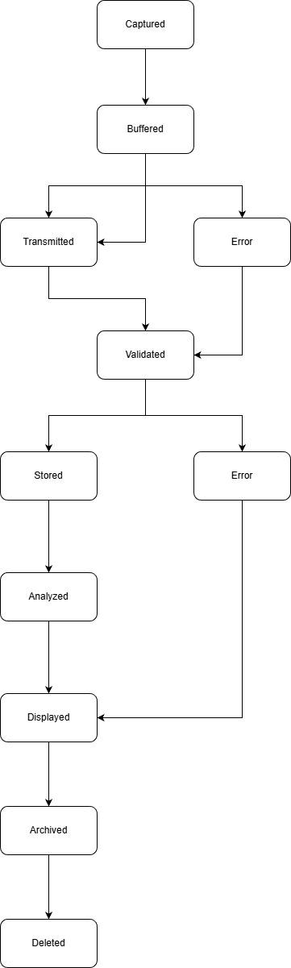State diagram (image lifecycle)

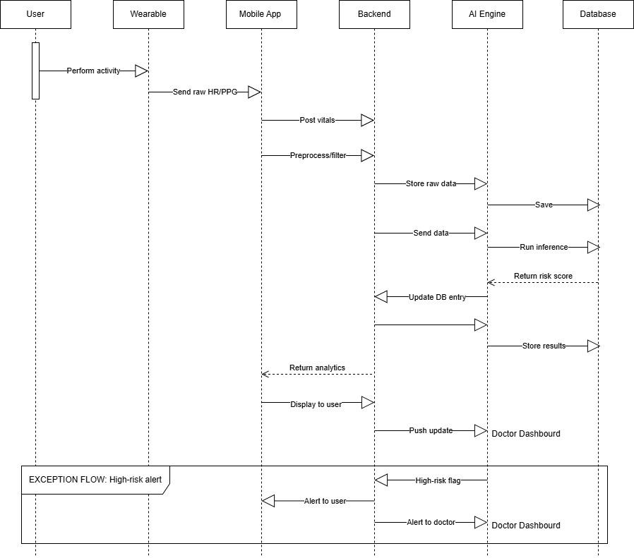
Sequence diagram (full pipeline)

Wireframes:

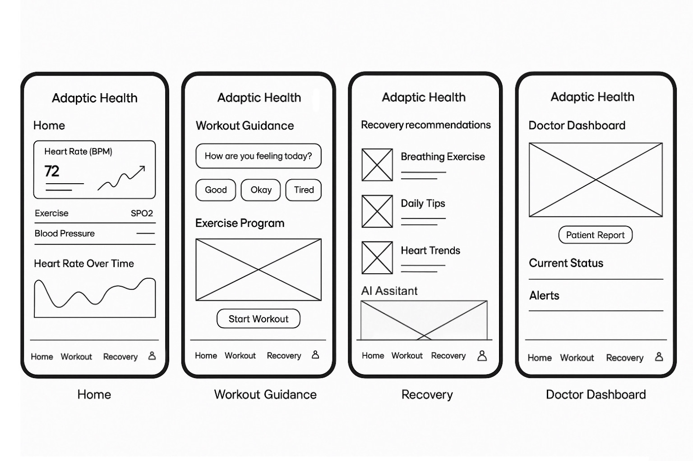

User workflow:

1. General User Flow (Home → Workout → Recovery)

- The user opens the app and lands on the Home screen.
- The user views key vitals such as:
- Heart Rate (BPM)
- Blood Pressure
- SPO2
- Heart Rate Over Time graph
- The user taps Workout from the bottom navigation bar.
- On the Workout Guidance screen:
- The user answers the wellness check (“How are you feeling today?”).
- The system adjusts workout difficulty accordingly.
- The user views the “Exercise Program”.
- The user taps Start Workout to begin the guided workout session.
- After completing the workout, the user taps Recovery in the bottom navigation bar.
- On the Recovery screen, the user reads:
- Breathing exercises
- Daily tips
- Heart trend lines
- The system uses the recovery data to adjust tomorrow’s workout.

2. Doctor Workflow
- The doctor opens the Doctor Dashboard.
- The doctor views the patient’s health overview graph.
- The doctor taps the Patient Report to access the detailed view.
- The doctor reads the patient’s Current Status section.
- The doctor reviews Alerts for any abnormalities or irregular heart activity.
- The doctor uses trends and alerts to make recommendations or follow-up decisions.

3. Workout Guidance Workflow
- The user navigates to Workout.
- The system prompts: “How are you feeling today?”
- The user selects Good, Okay, or Tired.
- The system adjusts workout intensity in real time.
- The user reviews the Exercise Program block.
- The user taps Start Workout.
- System logs workout activity and physiological responses.

4. Recovery Workflow
- The user opens the Recovery screen.
- The system displays:
- Breathing exercises
- Daily wellness tips
- Heart Trends (HR recovery graph)
- The user reads recommendations and follows any suggested exercises.
- Insights from the recovery screen feed directly into the next day's workout plan.

Requirements Traceability Matrix:

Requirement ID | Requirement Description | SDD Component/ Implementation | Wireframe Screen
REQ-1.1 | Display real-time heart rate | HR Display Module | Home
REQ-1.2 | Show historical heart-rate trend | Cardio Trend Graph | Home
REQ-1.3 | Provide navigation between modules | Bottom Navigation Bar | All Screens
REQ-1.4 | Collect user wellness input | Daily Check-in Component | Workout Guidance
REQ-1.5 | Generate personalized workout plans | Exercise Program Module | Workout Guidance
REQ-1.6 | Start and track workout sessions | Workout Session | Workout Guidance
REQ-1.7 | Display recovery recommendations | Recovery Recommendation Engine | Recovery
REQ-1.8 | Provide breathing exercises | Breathing Exercise Module | Recovery
REQ-1.9 | Display heart recovery trends | Heart Trends Graph | Recovery
REQ-1.10 | Allow the doctor to view patient data | Doctor Dashboard Module | Doctor Dashboard
REQ-1.11 | Display alerts (abnormal data) | Alerts Component | Doctor Dashboard
REQ-1.12 | Display patient status summary | Status Summary Module | Doctor Dashboard

